**Resume Builder Web Application**

**Team Leader:** Ravi Krishna Teja Dachepalli (16300464)

**Team members :**

1.Jayanth Golla

2.Ravi Krishna Teja Dachepalli

3.Anudeep Thippireddy

4.Manoj Desetty

**Project Description (Background Story):**

Individuals finding it difficult to create a resume from scratch , in any job application process or in any other business.It must be kept short, straightforward, and current with work experience, and it must be updated on a regular basis. One of my classmates found it hard to build and modify a resume every single time while applying for different on campus jobs. So , this made us think about an online web application that will automatically generate a good, correctly formatted resume from information entered into a form.

**Intended Modules or Plan:**

**Module I -** Designing user friendly web-application using html, javascript, bootstrap.

**Module II -** To work with the backend technologies and modules required to transform the user given input to formatted resume in pdf extension.

**Module III -** To deploy the web application after the results of Manual testing.

**Module IV - (Optional)**  To deploy the web application as a mobile application based on the course work and time.

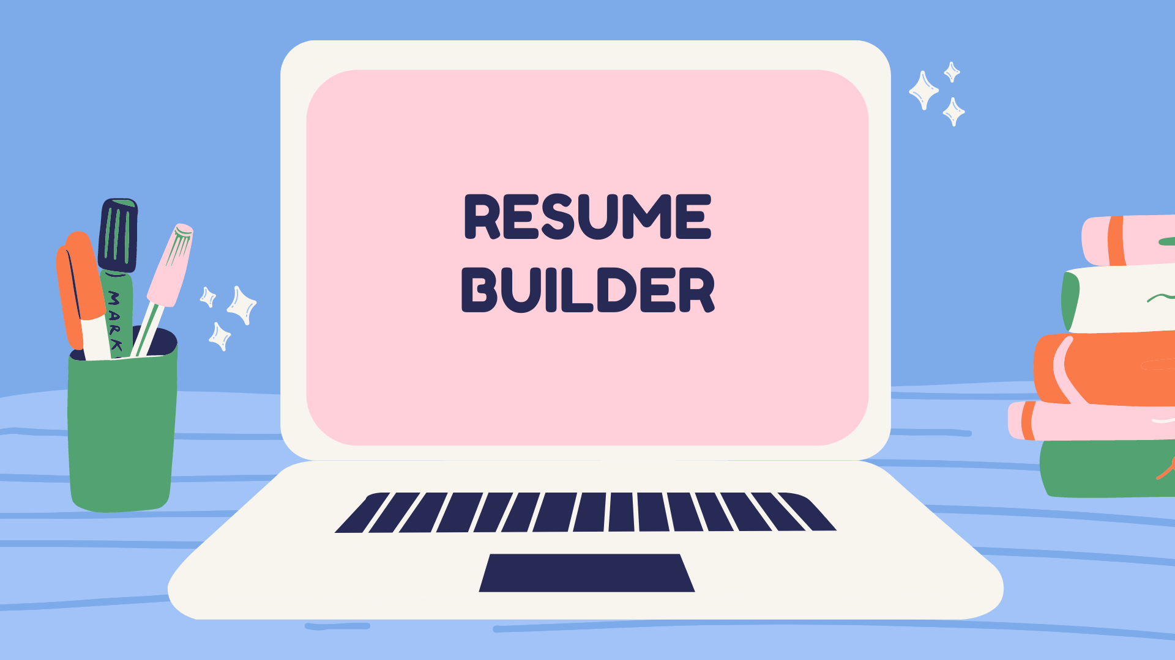

**Intended Project Flow (Step-by-Step):**

**Step-01:**  To select a template from the various sources and design UI with the help of template.

**Step-02:** To use Angular or React as a frontend framework.

**Step-03:** To use various modules and API’s to convert the user given input to pdf form.

**Step-04:** To useNode.js and Express for server side programming(if any) and to avoid code repetition.

**Step-05:** To deploy the web application after testing it manually. However, Unit testing is done at every step mentioned above.

**Step-06:** To deploy the application as a mobile application.

**Resume Builder Features:**

* Fast and accurate resume creation.
* Simple and accessible UI.
* Modifies raw input data into formatted resume.
* Users can select the format or template of the resume.
* Users can get the formatted output as a pdf document.

**Resume Builder Uses:**

* Users can get a well formatted resume in very less time.
* Users cannot skip or forget the key points in their resume with this resume builder.
* Application will be reliable and handy.
* Users can download their resume for free of cost.

**References :**

**Journal :** [**RESUME BUILDER APPLICATION**](https://www.jetir.org/view?paper=JETIREN06004)

**Resume Builder :** [**Create a Resume for Free With Our Online Resume Builder**](https://www.myperfectresume.com)

**Wikipedia :** [**Résumé - Wikipedia**](https://en.wikipedia.org/wiki/R%C3%A9sum%C3%A9)

**Javascript :** [**JavaScript | MDN**](https://developer.mozilla.org/en-US/docs/Web/JavaScript)

**Express JS :**

[**Express - Node.js web application framework**](https://expressjs.com/)